**Lab 7: Vibration Testing**

**Objective:**

The goal is to explore the dynamic response of a built-up wing using a load cell, accelerometer, and electromagnetic shaker. You will use a sinusoidal force of varying frequency to examine the structural response of this multi-degree of freedom system. The load cell will be used to measure the forcing applied by the electromagnetic shaker. The accelerometer will measure the wing’s acceleration in response to applied excitation. The lab handout provided in ***Lecture 16 and 17*** notes is below.

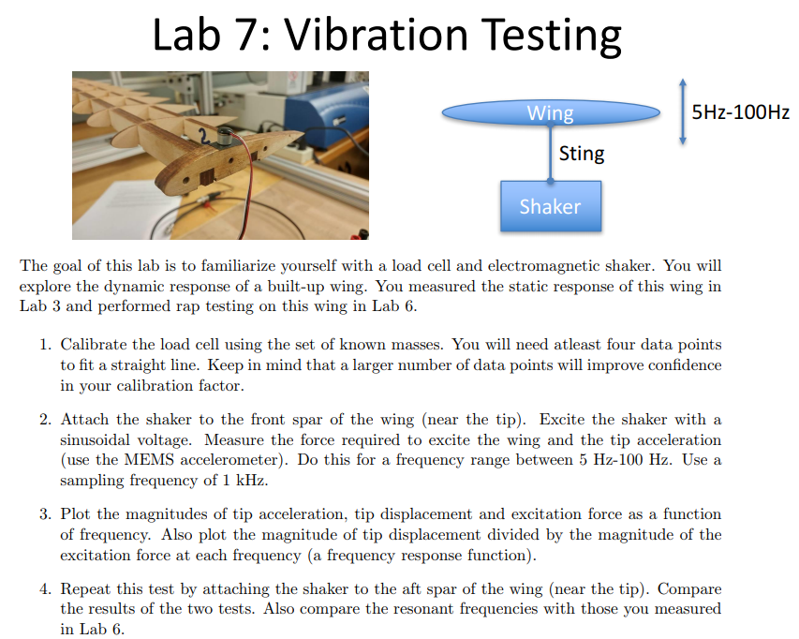

**Tools:**

1. ADXL335 MEMS Accelerometer
2. Load Cell LP703
3. Electromagnetic Shaker (Mechanical Vibrator SF-9324)
4. PCA1 Stereo Power Amplifier
5. NI 9215
6. NI 9218
7. NI 9982
8. Calibrated Mass Set
9. Rod/Screw to attach Electromagnetic Shaker
10. Magnet

**Procedure:**

1. Before conducting the vibration test, you will need to calibrate the load cell.
   1. Connect the load cell to the NI 9982 Screw Terminal: red wire to red terminal, black wire to black terminal, white wire to white terminal, and green wire to green terminal. Remember that this hardware is used to amplify the signal from the load cell. It also provides power/ground to the load cell.

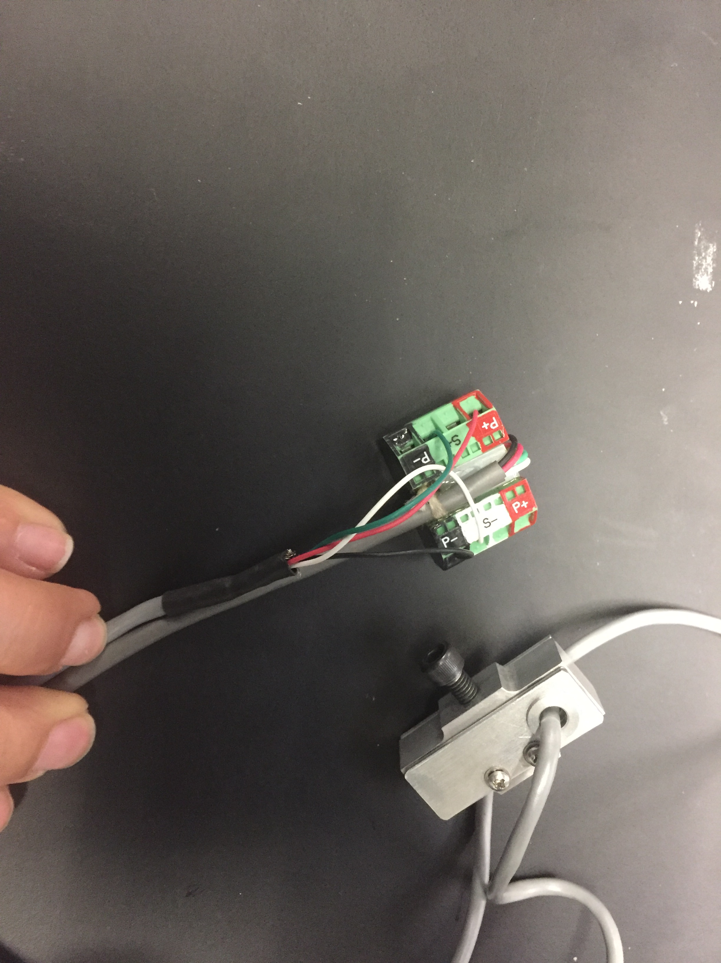

* 1. Connect the NI 9982 to the NI 9218.

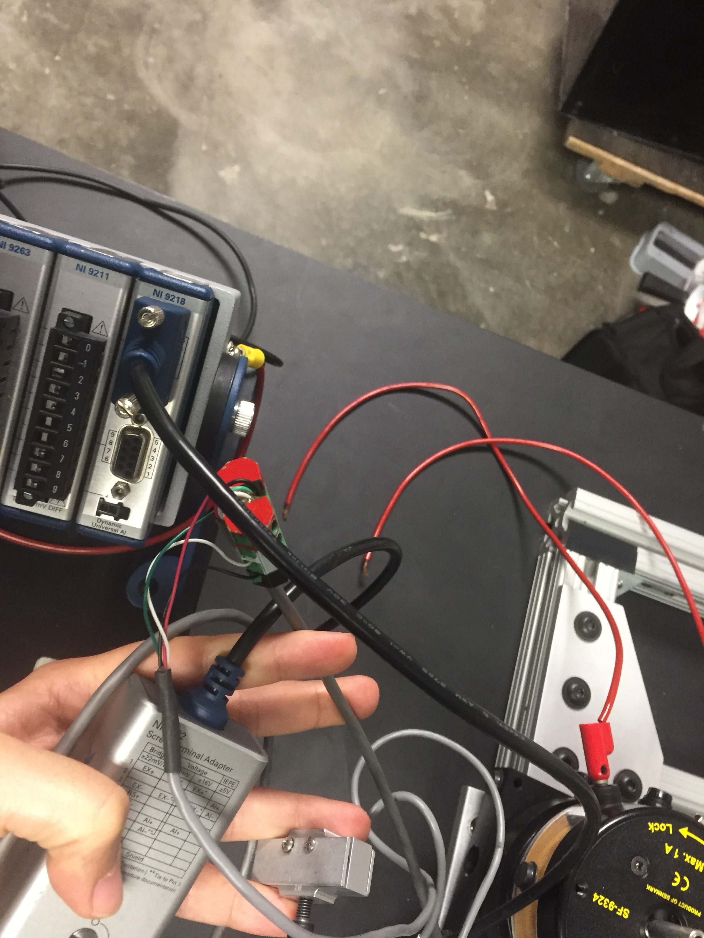

* 1. Create a LabVIEW VI to obtain the reading from the load cell. Insert the DAQ assistant block, which will be used to acquire an analog input signal. Select Bridge (V/V) and select channel connected to NI 9982. Settings for Bridge are below:

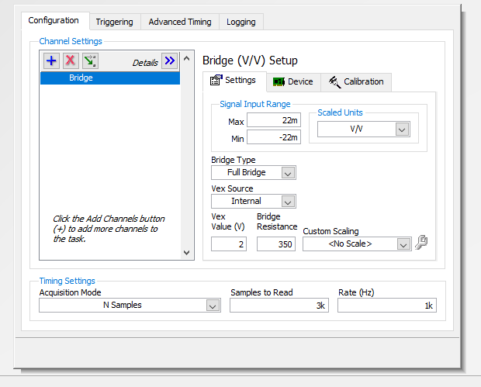

You can change the scaled units to (mv/V) or leave as (V/V). The FFT VI defaults to mV/V. Insert the collector block and change the number of samples to 100,000 (I randomly chose this value) when prompted. Connect the output of the DAQ assistant to the collector. Insert the statistics block, which will be used to display the mean and standard deviation of the load cell output, and connect to collector block. Use numeric indicators to visualize the mean and standard deviation of the load cell output. Use a graphical indicator to visualize the load cell output.

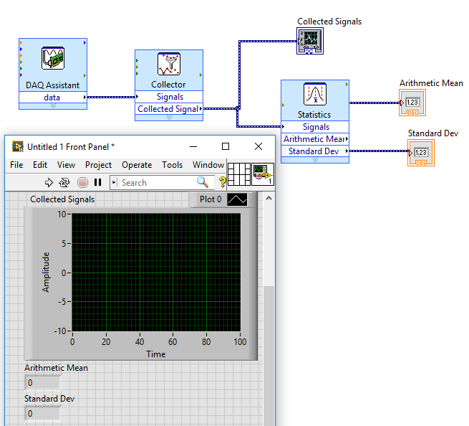

* 1. Connect the load cell to the calibration stand using a screw provided. Be careful to not overtighten the screw. Additionally, use a screw to attach a bracket to other side of the load cell.

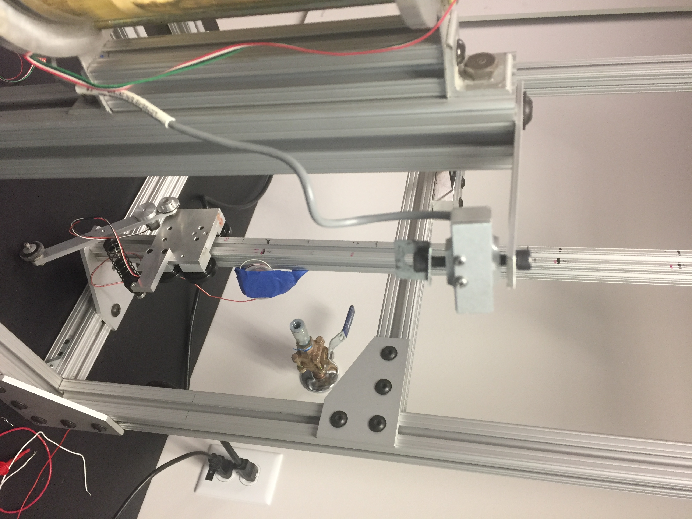

* 1. You will use the mass set to calibrate the load cell. Use 10 various masst values (0 and max value) for calibration. Each time you hang a weight: run the LabVIEW VI, record the weight value and the mean and standard deviation of load cell output in an Excel spreadsheet. You will plot the voltage outputs versus the weight values to obtain a calibration curve for the load cell. Note your voltage output units (mV or V depending on your settings).

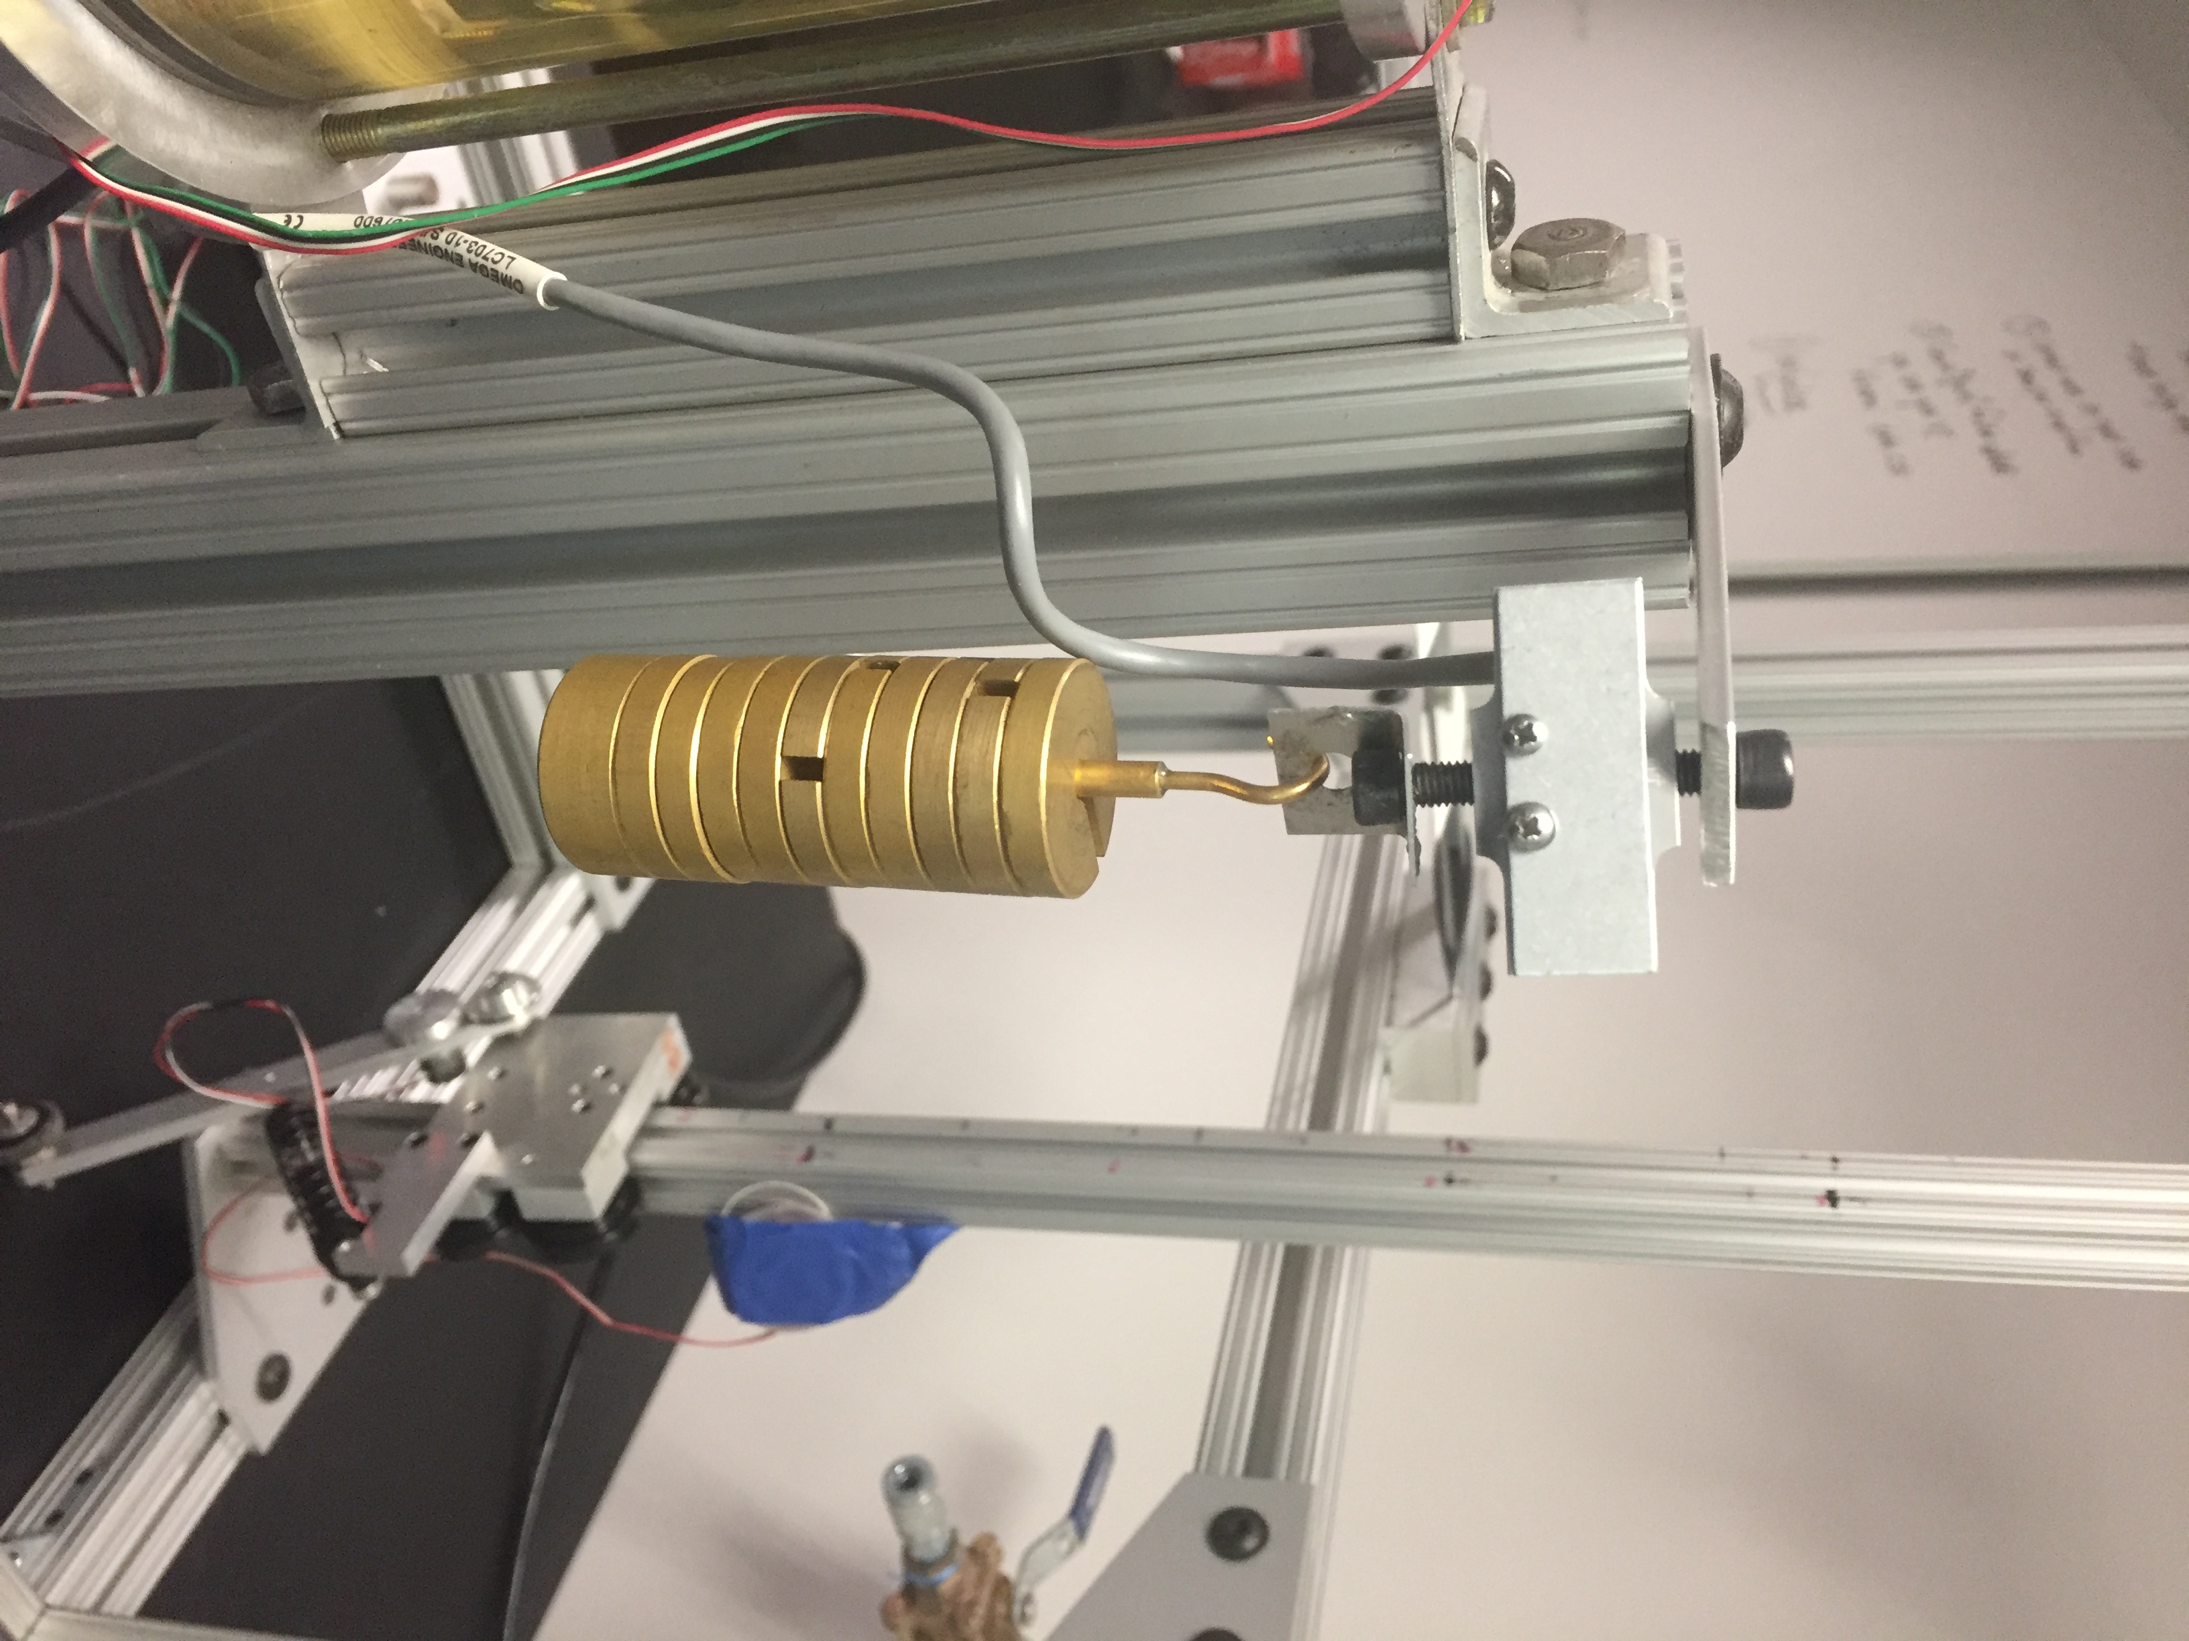

1. Connect the accelerometer to power and ground. Note the supply voltage and sensitivity from the datasheet. Set the variable side of the power supply to 3 V (check with multimeter). Connect the red wire of the accelerometer to power, the black wire to ground, and the green wire to channel a0 of the NI 9215. You will be provided with a LabVIEW VI that you will need to modify to obtain data from your accelerometer. Attach the accelerometer to the end ledge of the built-up wing in such a way that the x coordinate is measuring the vertical motion of the built-up wing.

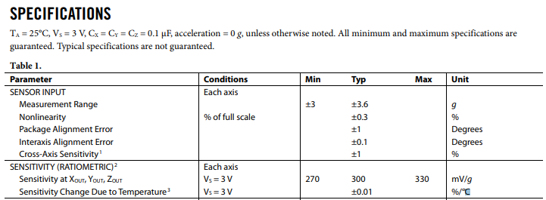

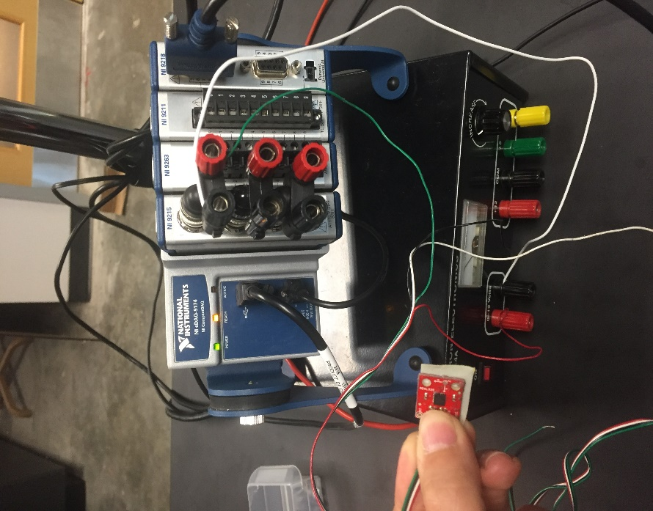

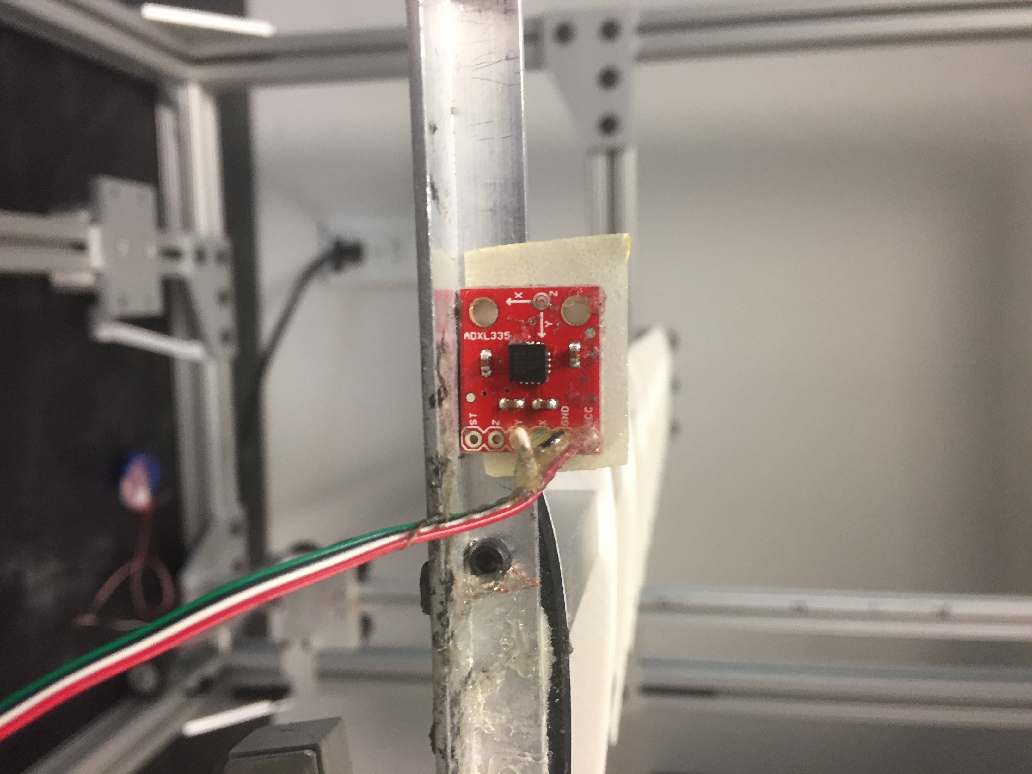

1. Connect channel a0 of the NI 9263 to the special cable for the Stereo Power Amplifier. Connect the BNC connector of the special cable to the Stereo Power Amplifier. Connect the Stereo Power Amplified to the wall outlet.

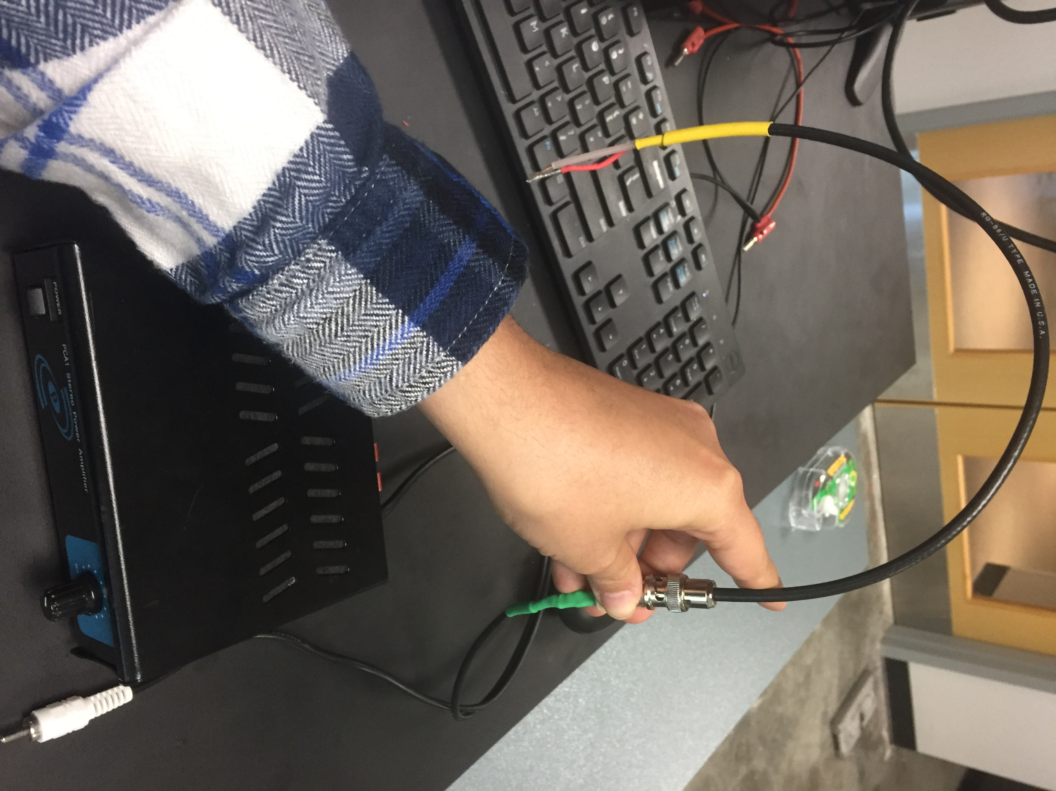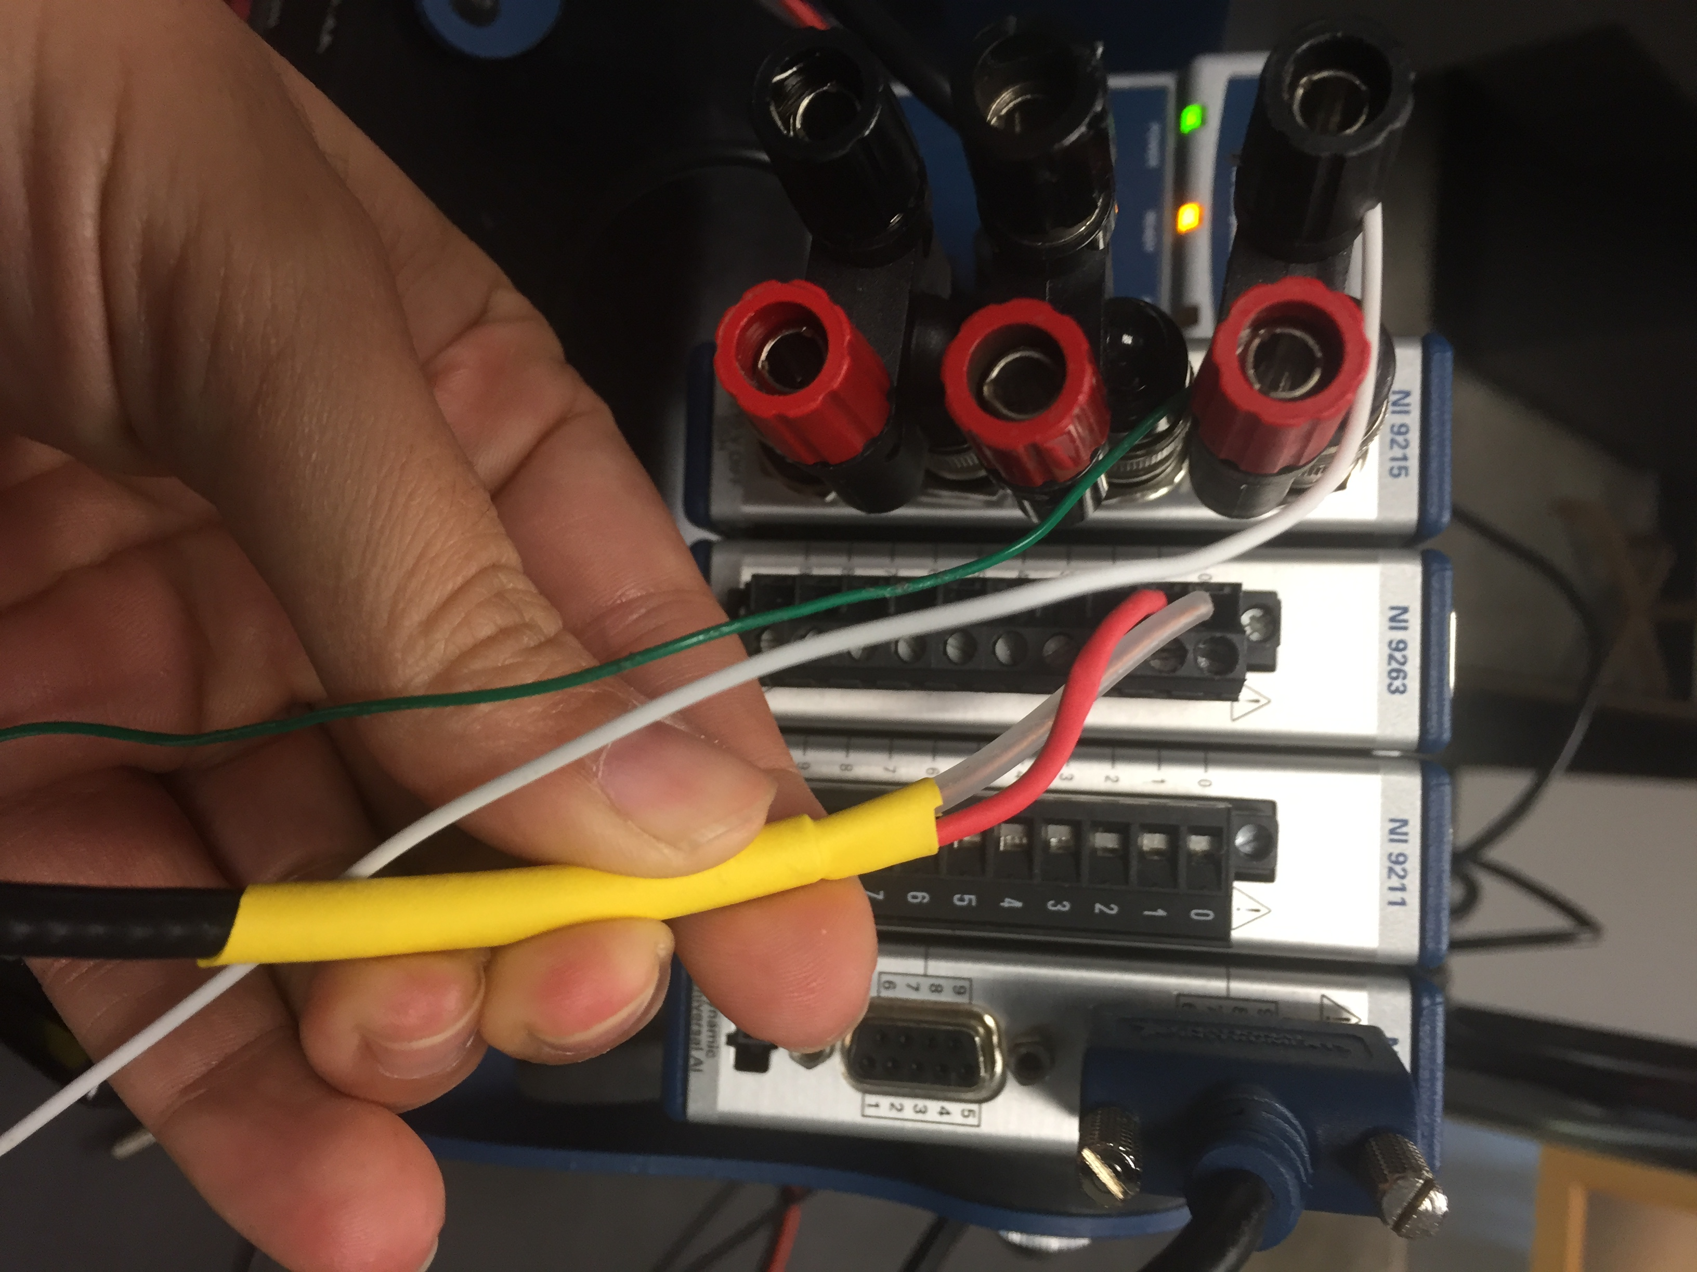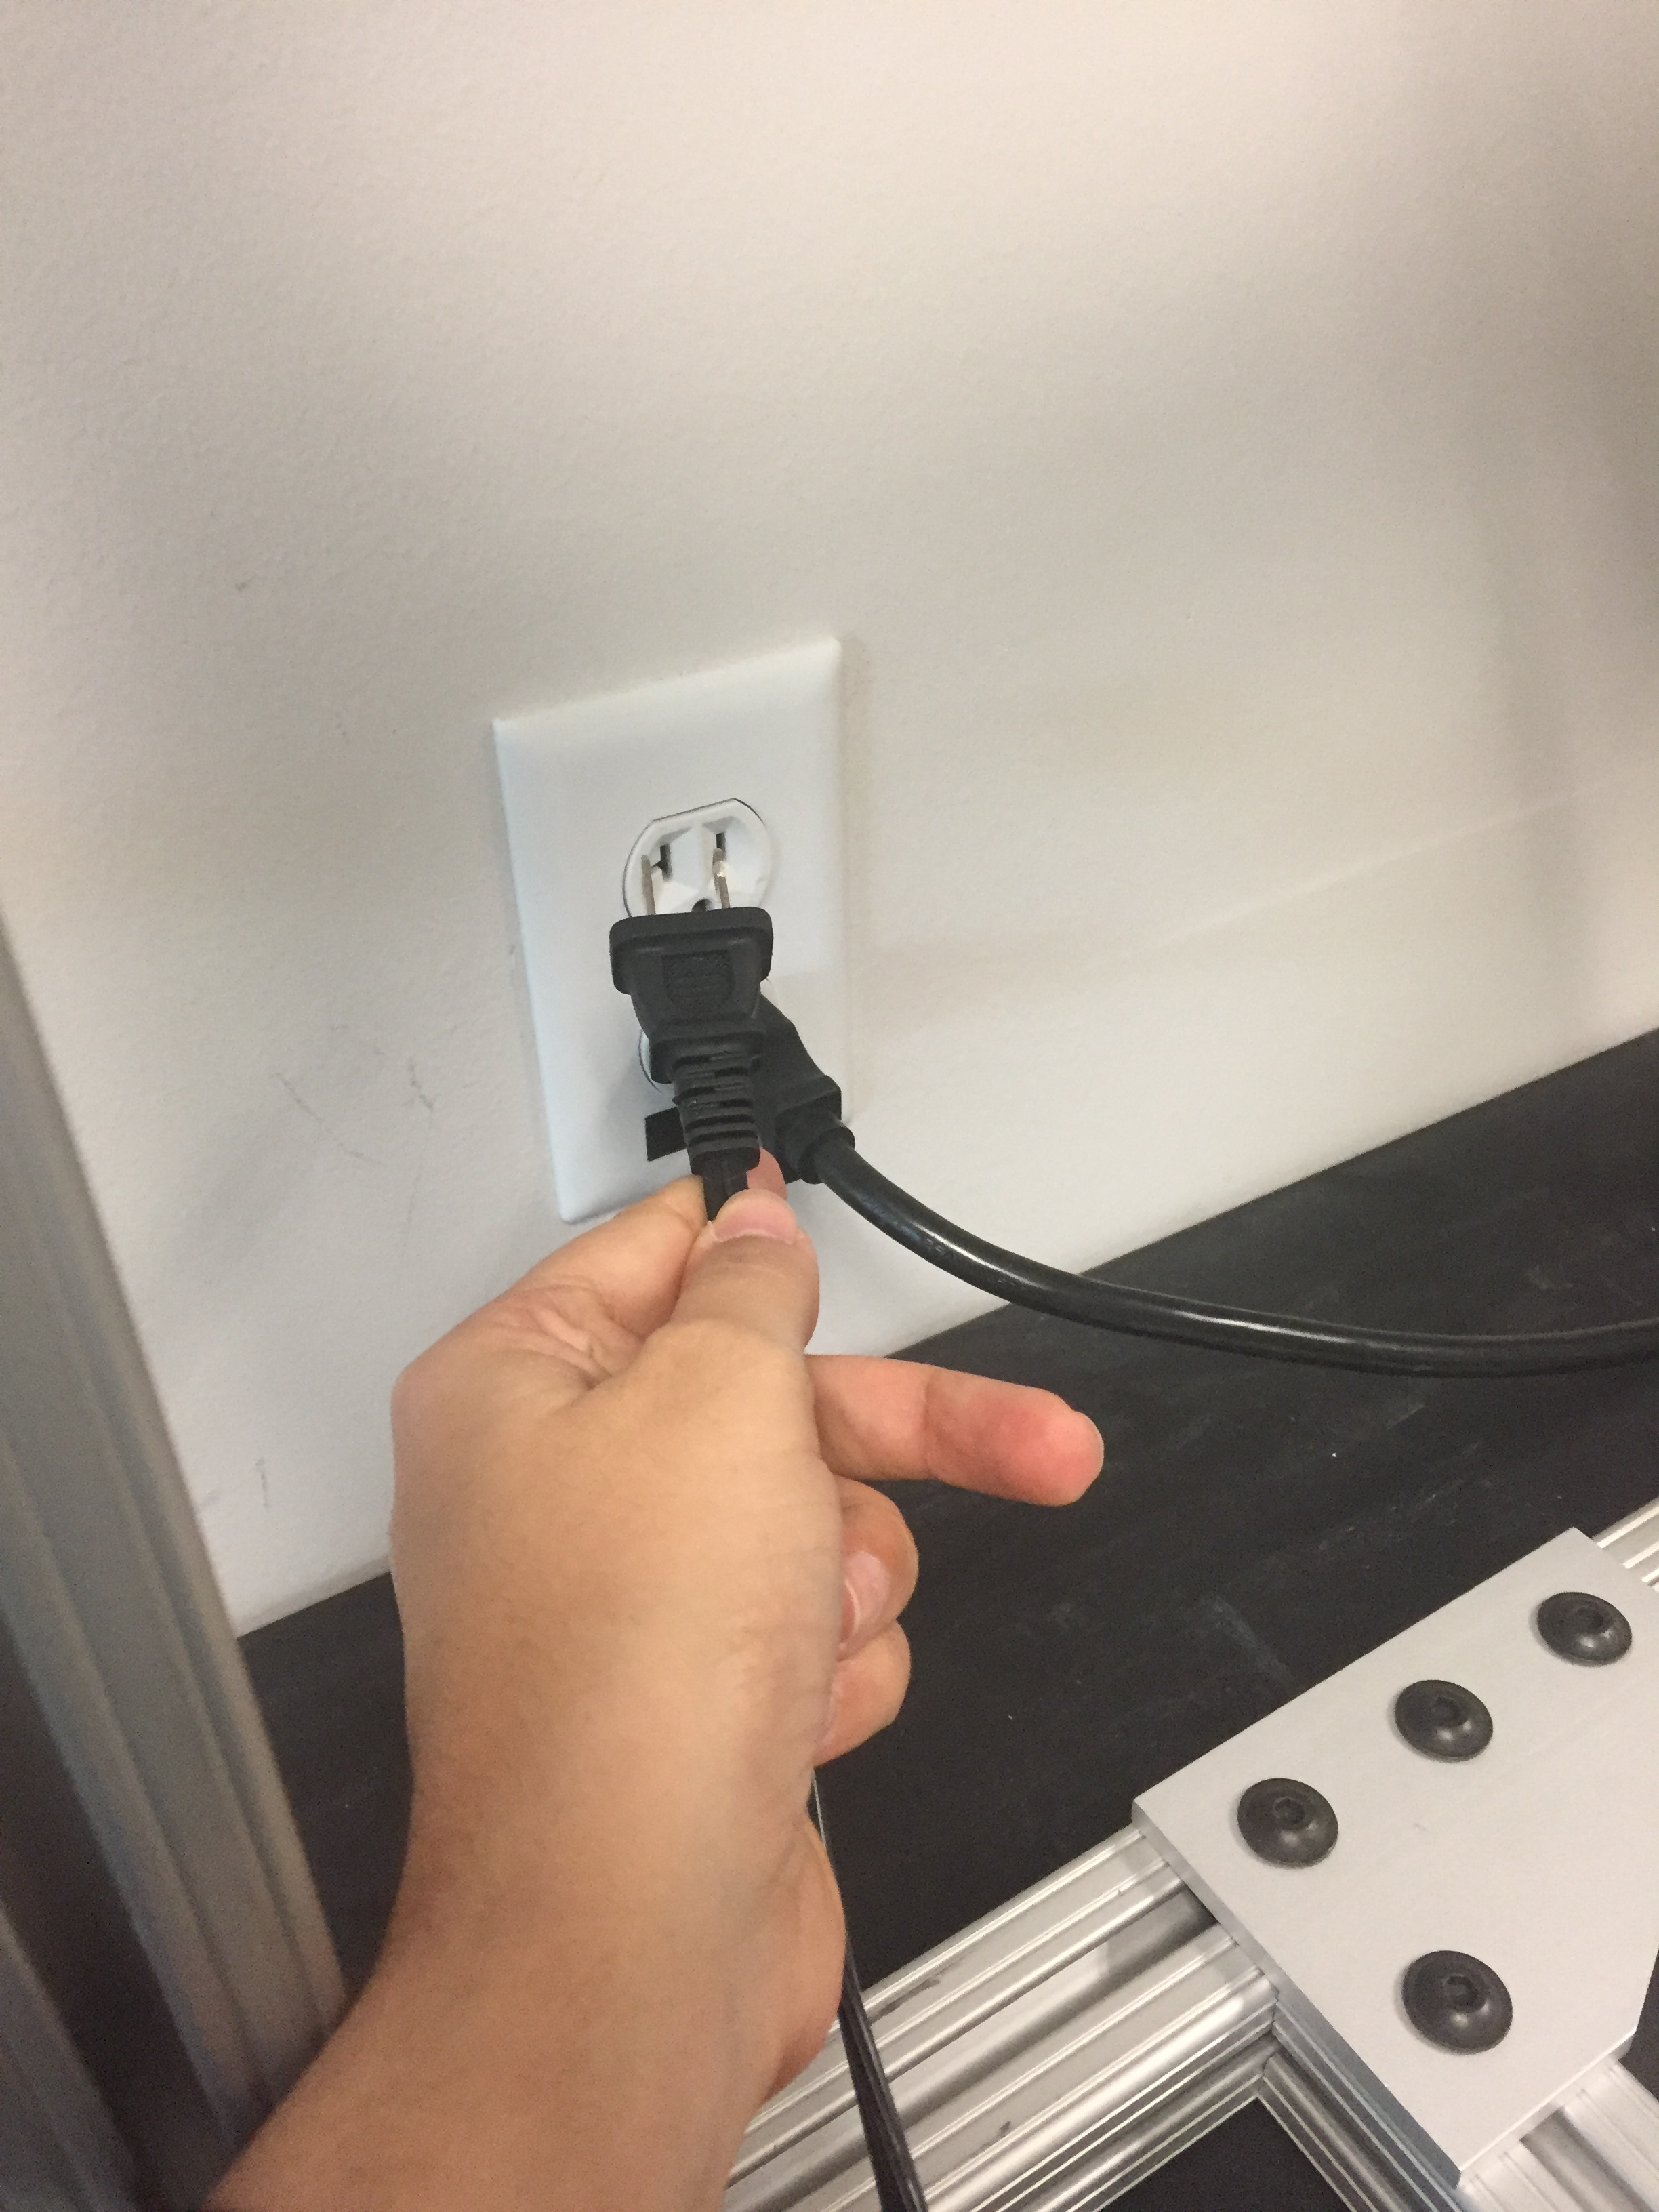

1. Connect the two red wires provided to the electromagnetic shaker and the ends to the Stereo Power Amplifier. You will need to modify the LabVIEW code provided to read in the correct channel of the NI 9263. You will attach the shaker to the A-frame using the attachment platform provided. Ensure you tighten the screw on the side of the shaker. Keep the shaker unlocked.

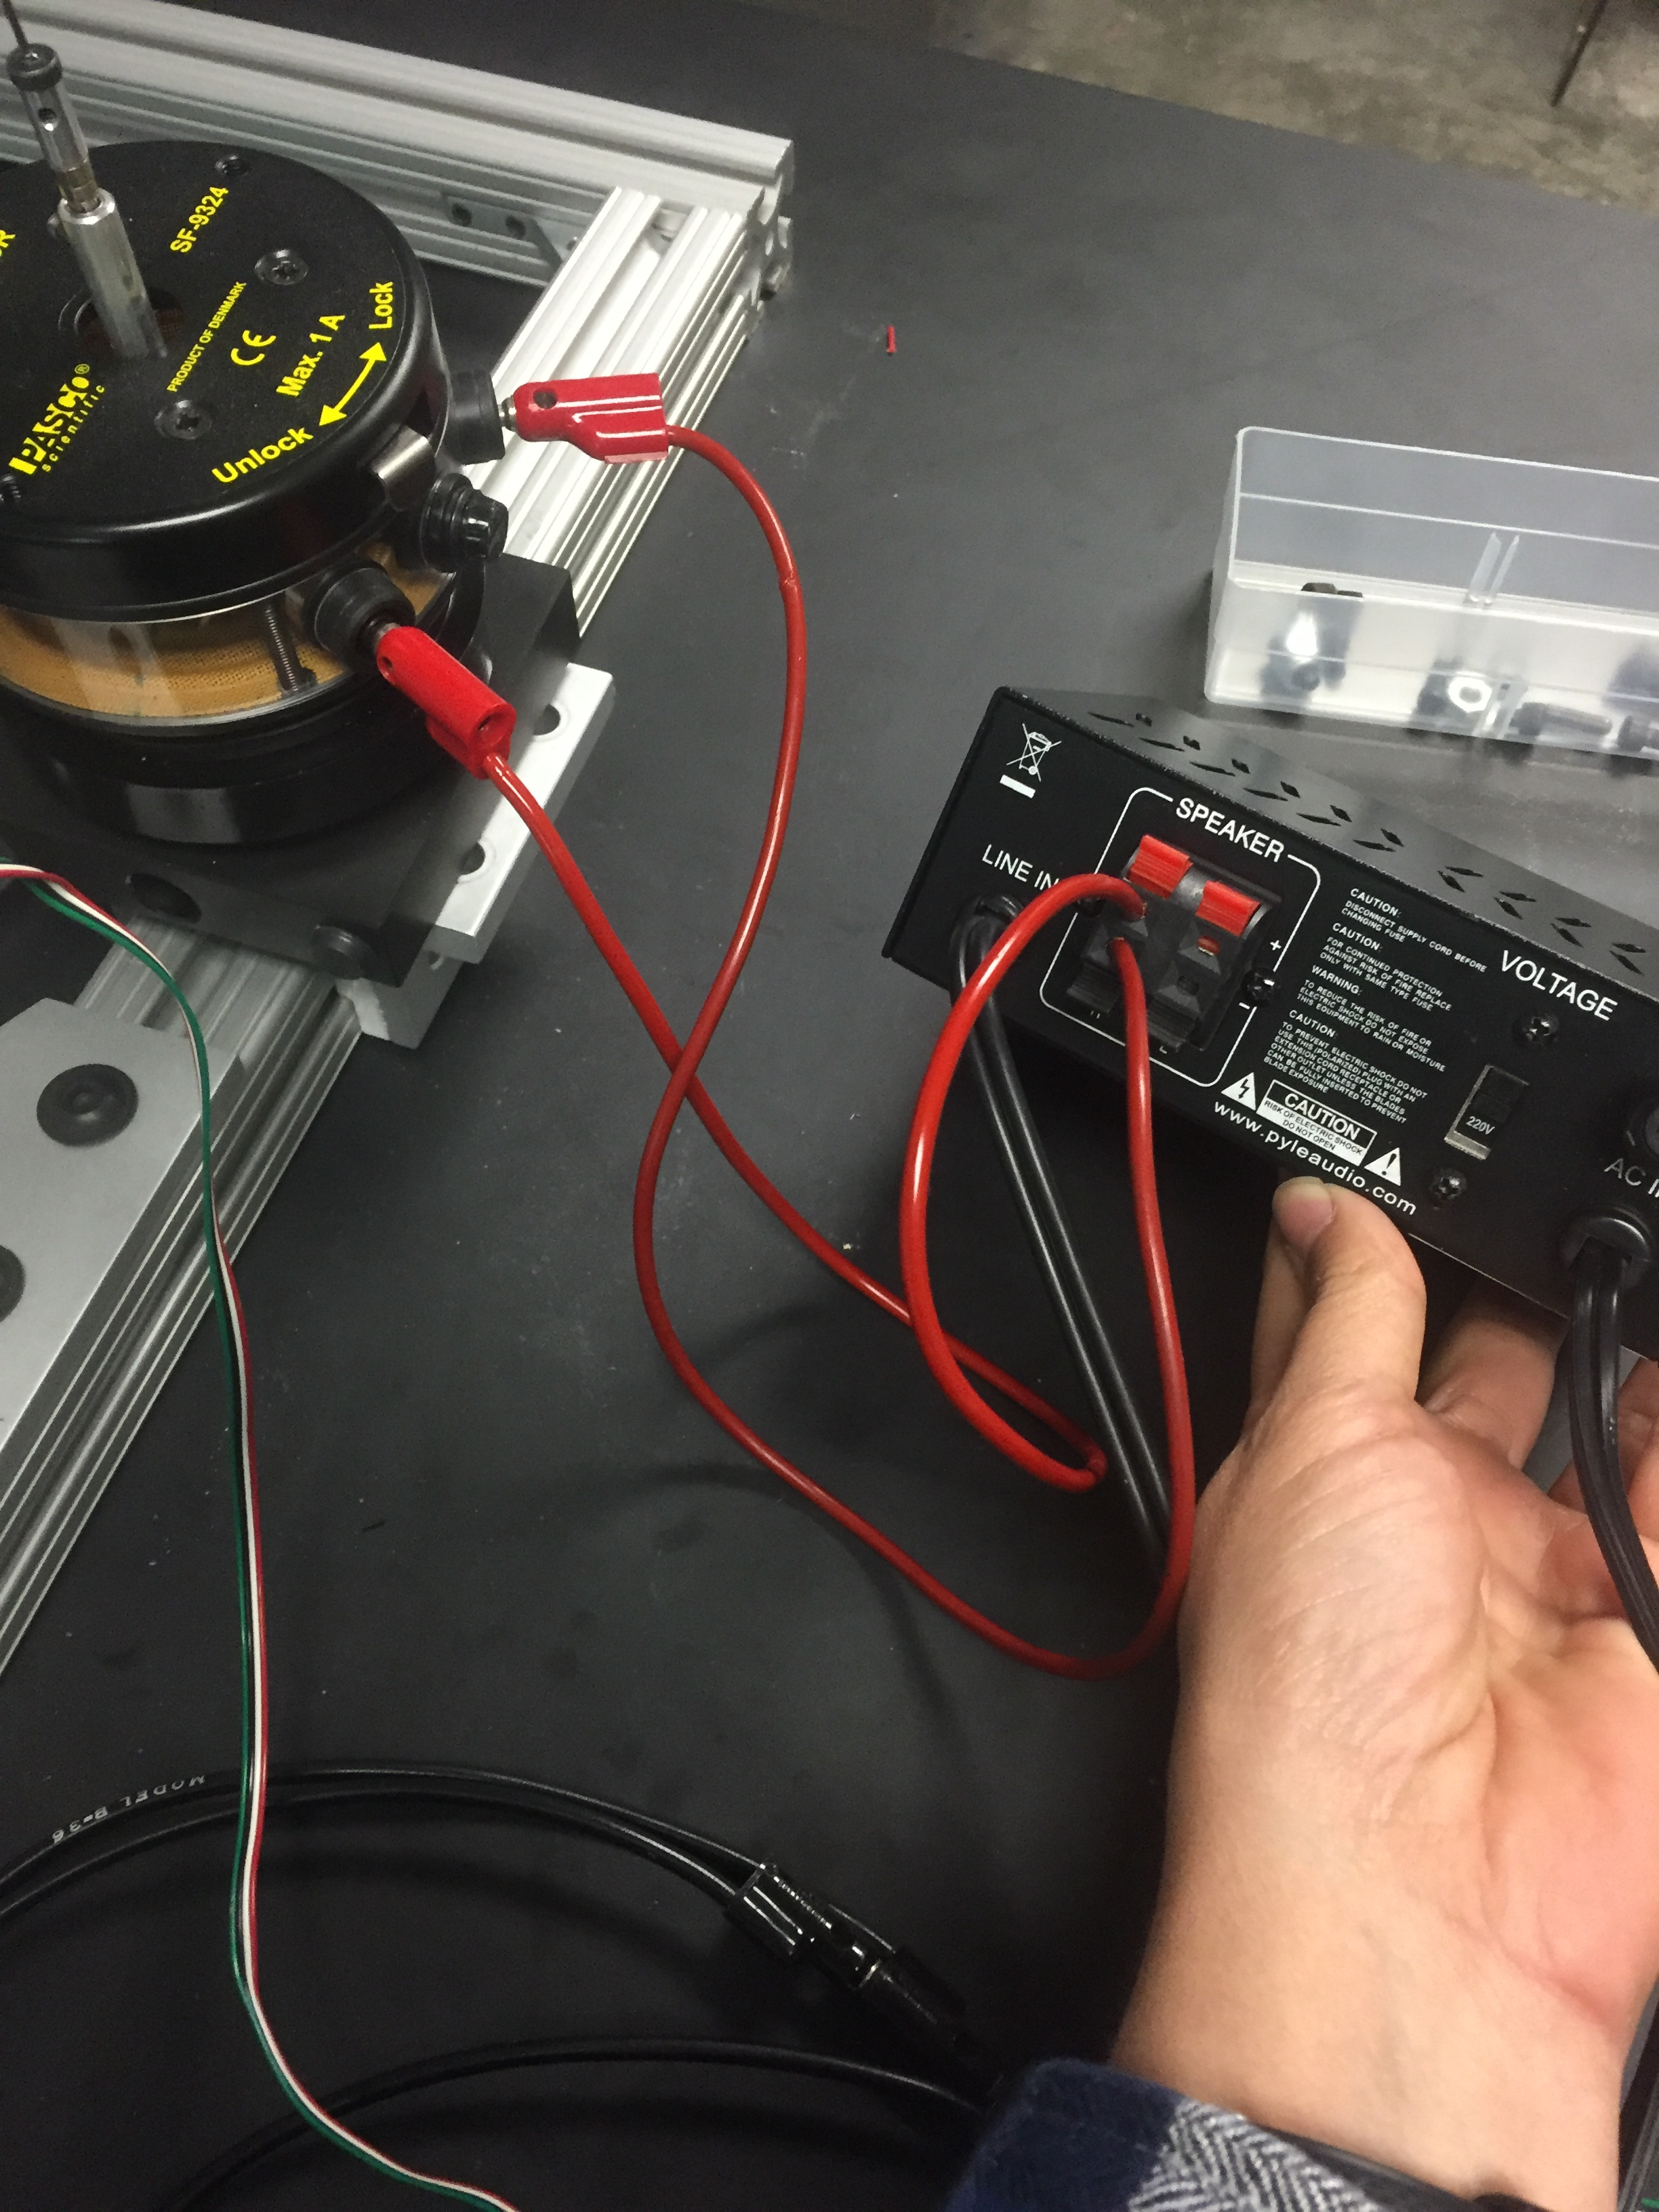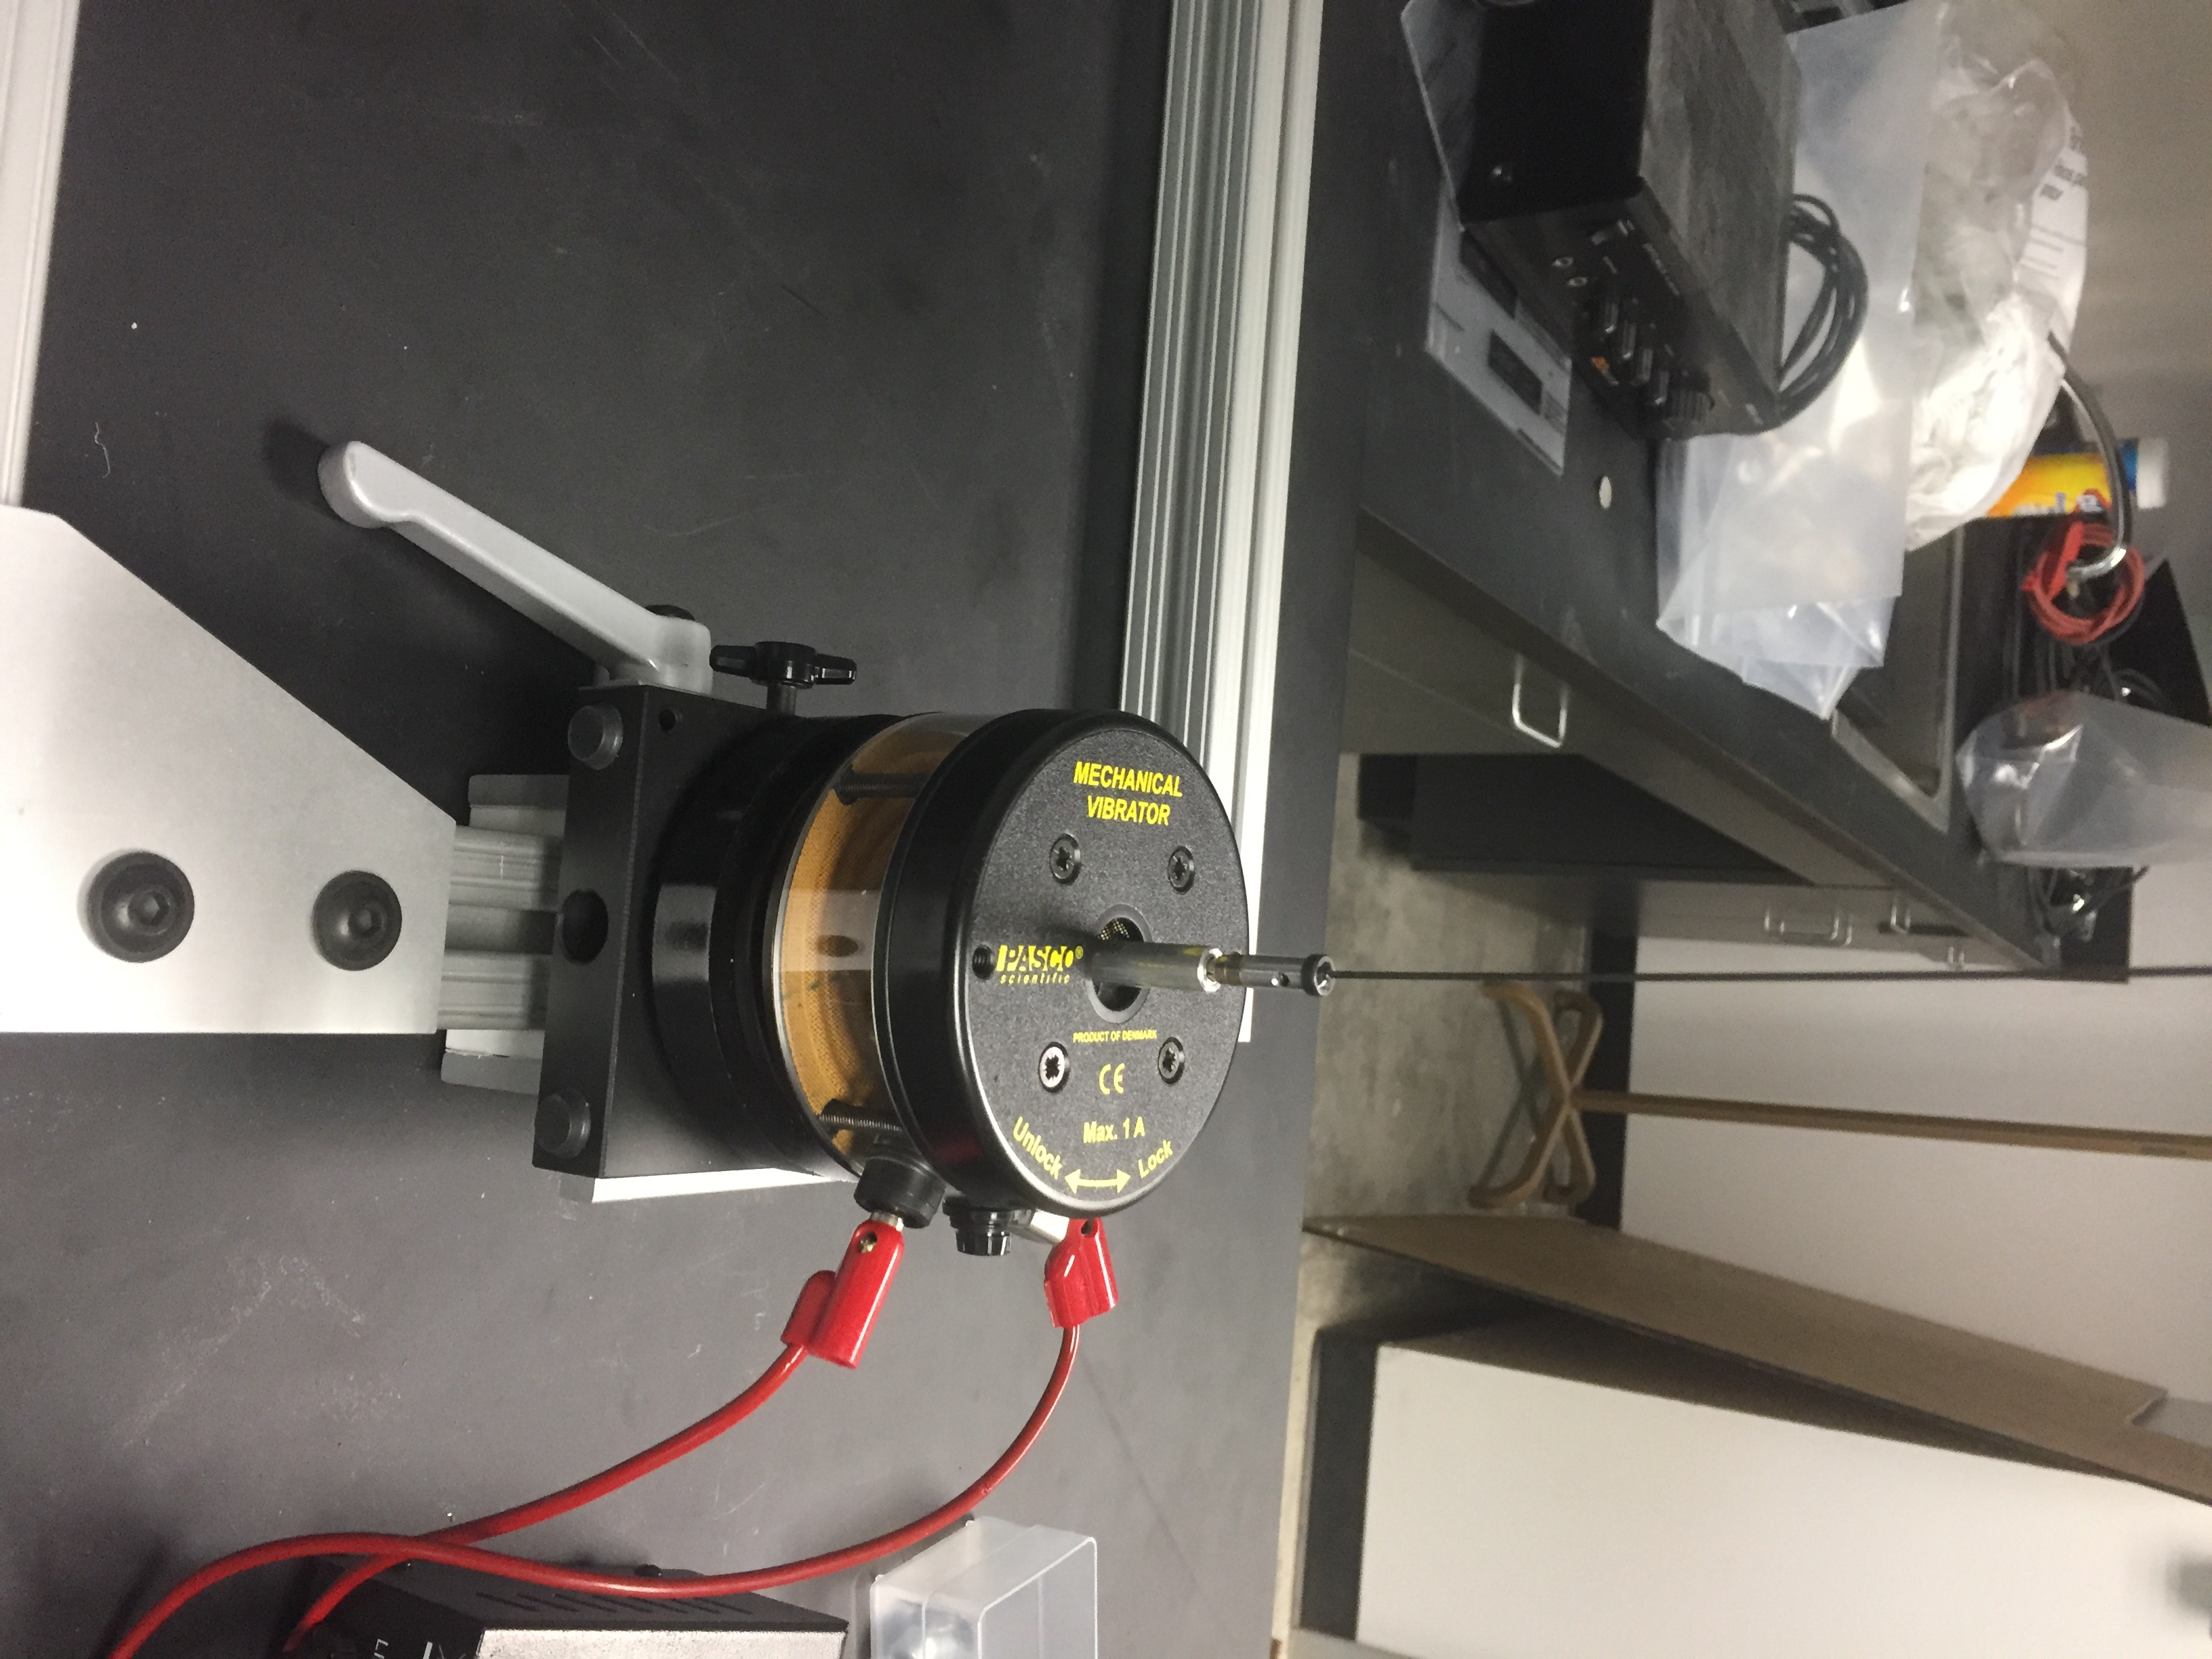

1. Attach the load cell to the end of the built up wing using a magnet/screw. Use the rod/screw provided to attach the shaker to the load cell.

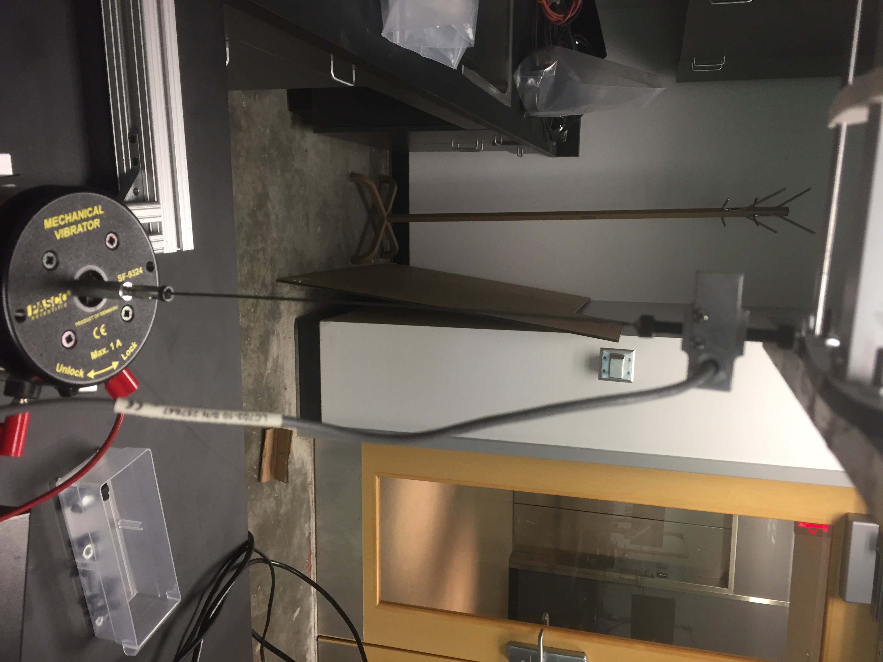

1. You will generate a sinusoidal signal using the LabVIEW GUI provided. You will sweep through frequencies of 5-100 Hz. Do this while the load cell/electromagnetic shaker is attached the front and back spar of the built-up wing. The LabVIEW VI will record the forcing, sinusoidal frequency, and acceleration data and output in excel file when you stop the program. Helpful VI info:
2. Before running VI, you will need to update your analog input channels/DAQ assistant settings. DO NOT change anything else in the back panel.

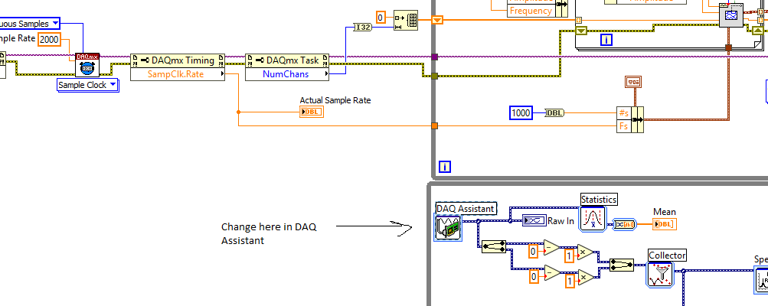

1. Note that the bridge settings are set to mV/V. You can change to V/V. Change name of Acc to MEMS X if you wish.
2. Create a folder where you have saved your VI named Data.
3. In the front panel, you will change the following:

Reselect cDAQ2Mod2/ao0.

Change the Amplitude to 1

Filename: data.csv

Start Freq: 5 Hz

End Freq: 100 Hz

Dwell Time: 4 s

To visualize bridge/MEMS data, you will need to select the waveform next to the signal and select plot visible.

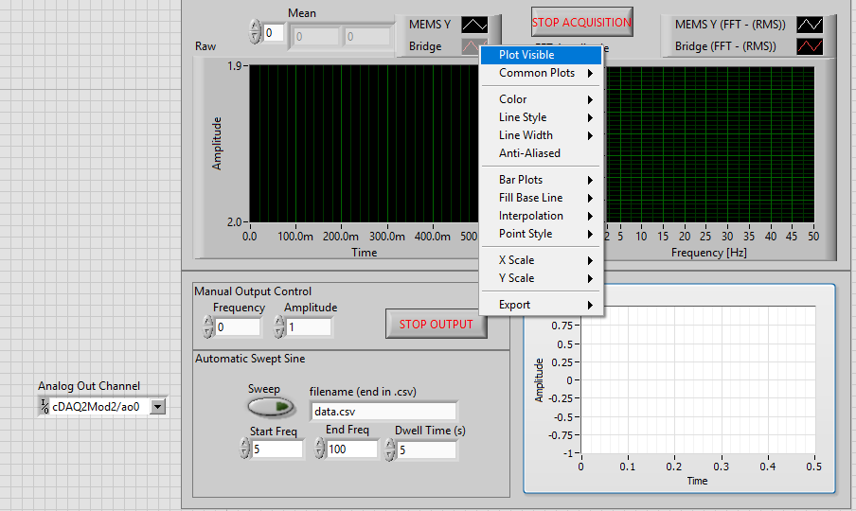

**Analysis:**

1. Integrate the acceleration data to find tip displacement. Plot acceleration, displacement, and excitation force against frequency. Also plot displacement divided by magnitude of excitation force against frequency. You will have plots for front and back spar data. You’ll need to determine the resonant frequencies and compare to lab 6 results. Make sure to read the lab handout provided in the lecture notes to ensure you’ve performed all analysis and answer all needed questions.